**DAILY ONLINE ACTIVITIES SUMMARY**

|  |  |  |  |  |  |  |  |  |
| --- | --- | --- | --- | --- | --- | --- | --- | --- |
| **Date:** | **16/07/2020** | | | | | **Name:** | **V ANJANA PAI** | |
| **Sem & Sec** | **IV sem & B section** | | | | | **USN:** | **4AL18CS094** | |
| **Online Test Summary** | | | | | | | | |
| **Subject** | | **-** | | | | | | |
| **Max. Marks** | | **30** | | **Score** | | | **-** | |
| **Certification Course Summary** | | | | | | | | |
| **Course** | **Predictive Modelling and Analytics** | | | | | | | |
| **Certificate Provider** | | | **Greatlearning academy** | | **Duration** | | | **5.5 hours** |
| **Coding Challenges** | | | | | | | | |
| **Problem Statement1: -----------------------------** | | | | | | | | |
| **Status: -------------------** | | | | | | | | |
| **Uploaded the report in Github** | | | | | **----------** | | | |
| **If yes Repository name** | | | | | **-------------** | | | |
| **Uploaded the report in slack** | | | | | **YES** | | | |

Online Test Summary: No internals conducted today.

Online Certification Course Summary: In today’s session I learnt about Logistic Regression-3.

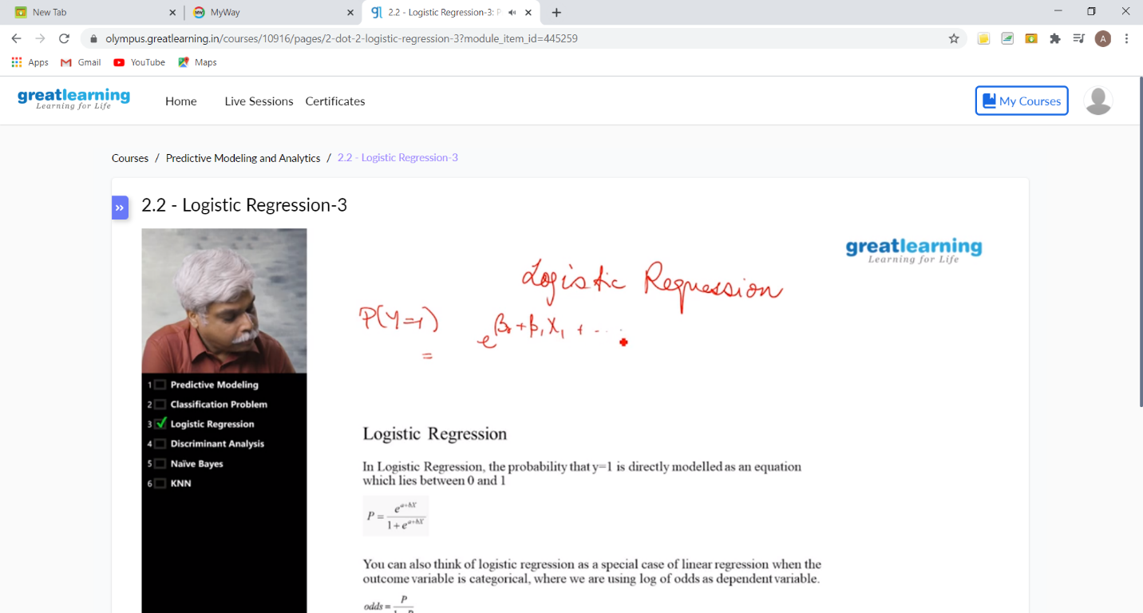

This is the snapshots of today’s session.

Online Coding Summary: **No problem statements given.**

Online Training: Today I had attended the online training organized by CSE Department AIET. The training was on C programming language done by Prof. Megha Hegde CSE Dept.